**USECASE SPECIFICATION**

**GROUP 01**

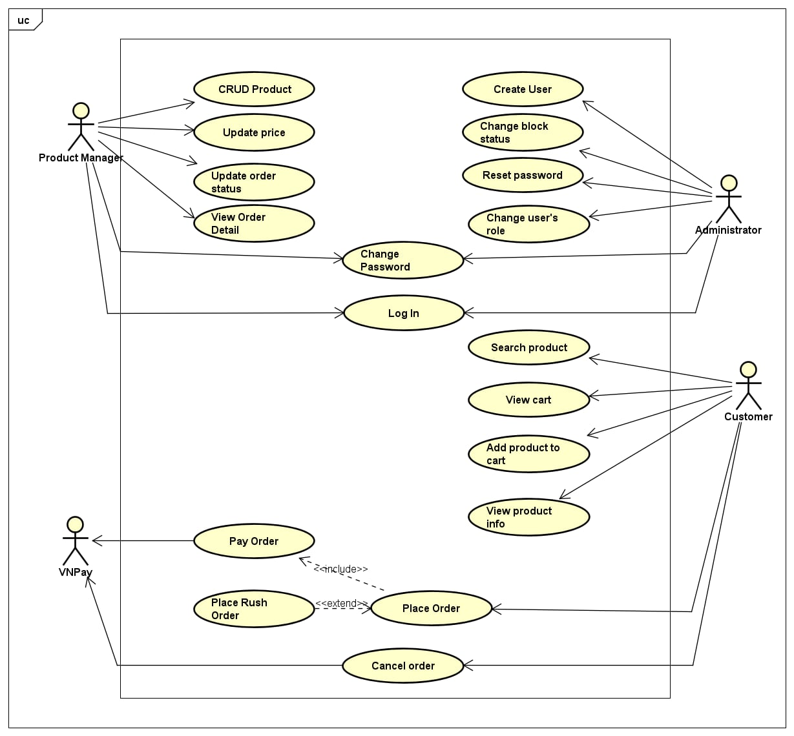

## 1. Use case – Place Order

| **Use case - Place Order**  **1. Use case code**  UC01  **2. Brief Description**  The use case describes the interactions between customers and AIMS software when the customer wants to place an order.  **3. Actors**  **3.1. Customer**  **4. Preconditions**  There is at least one item in the cart.  **5. Basic flow**  Step 1. Customer requests to place an order in the cart.  Step 2. AIMS software checks the availability of products in the cart.  Step 3. AIMS software displays the form of delivery information with order information.  Step 4. Customer enters and submits delivery information. (Table 1)  Step 5. AIMS software calculates and displays order and shipping fees. (Table 2)  Step 6. The customer confirms the invoice and asks to pay order.  Step 7. The AIMS software calls UC “Pay Order”.  Step 8. The AIMS software saves order and creates a new order.  Step 9. The AIMS software makes the cart empty.  Step 10. The AIMS software sends email about the order notification and information.  Step 11. The AIMS software displays the successful order notification, the order and the transaction information. (Table 3)  **6. Alternative flow**     | No | Location | Condition | Action | Resume Location | | --- | --- | --- | --- | --- | | 1. | At Step 3 | If the products are not available | The AIMS software notifies that the products in the cart are not available and stay at the use case “View cart” | Use case ends | | 2. | At Step 5 | If the delivery info is invalid | AIMS software notifies that the delivery info is invalid (blank or wrong format) | At Step 3 | | 3. | At Step 5 | If the user chooses to place a rush order | AIMS software inserts use case “Place rush order” | At Step 6 | | 4. | At Step 8 | If the order payment is not successful or goes back from payment | AIMS software notifies that the order payment is unsuccessful | At Step 5 |   **7. Input**    Table 1. Input data of delivery information   | No | Data fields | Description | Mandatory | Valid condition | Example | | --- | --- | --- | --- | --- | --- | | 1. | Receiver name |  | Yes |  | Mai Duc An | | 2. | Phone number |  | Yes | 10 digits | 0353024468 | | 3. | Province | Choose from a list | Yes |  | Hanoi | | 4. | Address |  | Yes |  | 1st Dai Co Viet, Hai Ba Trung, Hanoi | | 5. | Shipping instructions |  | No |  |  |   **8. Output data**  Table 2. Output data of order information and shipping fee   | No | Data fields | Description | Display format | Example | | --- | --- | --- | --- | --- | | 1. | Title | Title of a media product |  | DVD Phim Vượt ngục | | 2. | Price | Price of the corresponding media product | - Comma for thousands separator  - Positive integer  - Right alignment | 123,000 | | 3. | Quantity | Quantity of the corresponding media | - Positive integer  - Right alignment | 2 | | 4. | Amount | Total money of the corresponding media | - Comma for thousands separator  - Positive integer  - Right alignment | 246,000 | | 5. | Subtotal | Total amount of all products in the order | - Comma for thousands separator  - Positive integer  - Right alignment | 2,316,000 | | 6. | Shipping fee |  | - Comma for thousands separator  - Positive integer  - Right alignment | 30,000 |   Table 3. Output data of general information of order and transaction info   | No | Data fields | Description | Display format | Example | | --- | --- | --- | --- | --- | | 1. | Customer name |  |  | Mai Duc An | | 2. | Phone number |  |  | 0353024468 | | 3. | Province |  |  | Hanoi | | 4. | Address | Address of receiver |  | 1st Dai Co Viet, Hai Ba Trung, Hanoi | | 5. | Total amount | Total amount of all products in the order | Right alignment Vietnamese currency (VND)  Vietnamese locale | 1.200.000 VND | | 6. | Transaction ID |  |  |  | | 7. | Transaction content |  |  |  | | 8. | Transaction date |  | dd/mm/yyyy | 09/03/2024 |   **9. Postconditions**  A new order is created, and its information is sent via email to the customer. |
| --- | --- | --- | --- | --- | --- | --- | --- | --- | --- | --- | --- | --- | --- | --- | --- | --- | --- | --- | --- | --- | --- | --- | --- | --- | --- | --- | --- | --- | --- | --- | --- | --- | --- | --- | --- | --- | --- | --- | --- | --- | --- | --- | --- | --- | --- | --- | --- | --- | --- | --- | --- | --- | --- | --- | --- | --- | --- | --- | --- | --- | --- | --- | --- | --- | --- | --- | --- | --- | --- | --- | --- | --- | --- | --- | --- | --- | --- | --- | --- | --- | --- | --- | --- | --- | --- | --- | --- | --- | --- | --- | --- | --- | --- | --- | --- | --- | --- | --- | --- | --- | --- | --- | --- | --- | --- | --- | --- | --- | --- | --- | --- | --- | --- | --- | --- | --- | --- | --- | --- | --- | --- | --- | --- | --- | --- | --- | --- | --- | --- | --- | --- | --- | --- | --- | --- | --- | --- | --- | --- | --- | --- |

## 2. Use case – Pay Order

| **Use case - Pay Order**  **1. Use case code**  UC02  **2. Brief Description**  The use case describes the interactions between AIMS software with the customer and VNPay when the customer desires to pay an order.  **3. Actors**  **3.1. Customer**  **3.2. VNPay**  **4. Preconditions**  The customer has confirmed the invoice. AIMS software has calculated the total amount of money that the customer has to pay.  **5. Basic flow**  Step 1. AIMS software displays the invoice (Table 1).  Step 2. Customer asks to pay the invoice.  Step 3. AIMS software redirects to VNPay with payment information.  Step 4. VNPay notifies the transaction result. (Table 2)  Step 5. AIMS software saves the payment transaction.  **6. Alternative flow**     | No | Location | Condition | Action | Resume Location | | --- | --- | --- | --- | --- | | 1. | At Step 5 | If the customer cancels the payment transaction |  | At Step 1 |   **7. Input**  Table 1. Input data of payment information   | No | Data fields | Description | Mandatory | Valid condition | Example | | --- | --- | --- | --- | --- | --- | | 1. | Card holder name |  | Yes |  | Mai Duc An | | 2. | Card number |  | Yes | 16 digits | 1234 5678 9876 5432 | | 3. | Expiration date | The month, year of card expiration | Yes | mm/yy | 12/26 | | 4. | Security code |  | Yes |  | 123456 |   **8. Output data**  Table 2. Output data of general information of order and transaction info   | No | Data fields | Description | Display format | Example | | --- | --- | --- | --- | --- | | 1. | Title | Title of a media product |  | DVD Phim Vượt ngục | | 2. | Price | Price of the corresponding media product | - Comma for thousands separator  - Positive integer  - Right alignment | 123,000 | | 3. | Quantity | Quantity of the corresponding media | - Positive integer  - Right alignment | 2 | | 4. | Amount | Total money of the corresponding media | - Comma for thousands separator  - Positive integer  - Right alignment | 246,000 | | 5. | Subtotal before VAT | Total amount of all products in the cart before VAT | 2,106,000 | | 6. | Subtotal | Total amount of all products in the cart with VAT | 2,316,000 | | 7. | Shipping fee |  | 30,000 | | 8. | Total | Sum of subtotal and shipping fees | 2,346,000 | | 9. | Currency |  |  | VND | | 10. | Name |  |  | Mai Duc An | | 11. | Phone number |  |  | 0123456789 | | 12. | Province |  |  | Hanoi | | 13. | Address |  |  | 1st Dai Co Viet, Hai Ba Trung, Hanoi | | 14. | Shipping instructions |  |  |  |   **9. Postconditions**   * · AIMS software notifies successful payment. * · Order details are stored in the system. * · An email of successful order sent to. |
| --- | --- | --- | --- | --- | --- | --- | --- | --- | --- | --- | --- | --- | --- | --- | --- | --- | --- | --- | --- | --- | --- | --- | --- | --- | --- | --- | --- | --- | --- | --- | --- | --- | --- | --- | --- | --- | --- | --- | --- | --- | --- | --- | --- | --- | --- | --- | --- | --- | --- | --- | --- | --- | --- | --- | --- | --- | --- | --- | --- | --- | --- | --- | --- | --- | --- | --- | --- | --- | --- | --- | --- | --- | --- | --- | --- | --- | --- | --- | --- | --- | --- | --- | --- | --- | --- | --- | --- | --- | --- | --- | --- | --- | --- | --- | --- | --- | --- | --- | --- | --- | --- | --- | --- | --- | --- | --- | --- | --- | --- | --- | --- |

## 3. Use case – Place Rush Order

| **Use case - Place Rush Order**  **1. Use case code**  UC03  **2. Brief Description**  The use case describes the interactions between AIMS software with the customer when the customer wishes to place a rush order which allows them to receive the order within a shorter time frame.  **3. Actors**  **3.1. Customer**  **4. Preconditions**  The customer has provided the delivery information and wants to place a rush order.  **5. Basic flow**  Step 1. The customer requests to place a rush order.  Step 2. AIMS software checks the address that is supported for the selected product and delivery address.  Step 3. AIMS software prompts the customer to update the delivery information.  Step 4. Customer provides rush order delivery information. (Table 1)  Step 5. AIMS Software verifies the customer rush order information and calculates rush order shipping fee.  **6. Alternative flow**     | No | Location | Condition | Action | Resume Location | | --- | --- | --- | --- | --- | | 1. | At Step 2 | If rush order is not supported for shipping address or selected product | The AIMS software notifies the customer that rush order is not supported | Continue Use case “Place an order” with normal delivery. | | 2. | At Step 5 | If the delivery address is not supported | The AIMS software notifies the address is not supported for rush order | At Step 3 |   **7. Input**  Table 1. Input data of rush order information   | No | Data fields | Description | Mandatory | Valid condition | Example | | --- | --- | --- | --- | --- | --- | | 1. | Delivery time |  | Yes |  | 14h | | 2. | Delivery instructions |  | Yes |  |  |   **8. Output data**  **9. Postconditions**   * · Customer places rush order successfully. * · Customer continues at payment step. |
| --- | --- | --- | --- | --- | --- | --- | --- | --- | --- | --- | --- | --- | --- | --- | --- | --- | --- | --- | --- | --- | --- | --- | --- | --- | --- | --- | --- | --- | --- | --- | --- | --- | --- |

## 4. Usecase - Cancel Order

| **Use Case “Cancel Order”**  1. **Use case code**  UC04  2. **Brief Description**  This use case describes the interactions between the customer and the AIMS software when the customer wants to cancel an existing order.  3. **Actors**  3.1. **Customer**  4. **Preconditions**  The customer must have an existing order that is eligible for cancellation (i.e., the order has not yet been shipped or processed beyond the point of cancellation).  5. **Basic Flow of Events**   * 1. The customer accesses their order history.   2. The AIMS software displays a list of the customer's orders.   3. The customer selects the order they wish to cancel.   4. The AIMS software displays the order details and a cancellation option.   5. The customer requests to cancel the order.   6. The AIMS software verifies the order's cancellation eligibility.   7. The AIMS software processes the cancellation request.   8. The AIMS software updates the order status to "Cancelled".   9. The AIMS software sends an email notification to the customer about the cancellation.   10. The AIMS software displays a confirmation message to the customer.   11. **Alternative flows**  **Table N-Alternative flows of events for UC Cancel Order**   | **No** | **Location** | **Condition** | **Action** | **Resume location** | | --- | --- | --- | --- | --- | | 1 | At Step 6 | If the order is not eligible for cancellation (e.g., already shipped). | · Software notify | End usecase |   **6.** **Input data**  **Table A-Input data of …**   | **No** | **Data fields** | **Description** | **Mandatory** | **Valid condition** | **Example** | | --- | --- | --- | --- | --- | --- | | 1 | Order ID | Unique identifier for the order | Yes | Valid order ID | ORD123456 | | 2 | Reason for Cancellation | Customer's reason for cancelling the order | No |  | Changed my mind, Found a better price |   8. **Output data**  **Table B-Output data of …**   | **No** | **Data fields** | **Description** | **Display format** | **Example** | | --- | --- | --- | --- | --- | | 1 | Order ID   |  | | --- | | Unique identifier for the order   |  | | --- | |  | ORD123456 | | 2 | Order Status | | Current status of the order | | --- |      |  | | --- | |  | Cancelled | | 3 | | Cancellation Confirmation Message | | --- |      |  | | --- | | | Confirmation message displayed to the customer | | --- |      |  | | --- | |  | | Your order has been successfully cancelled. | | --- |      |  | | --- | | | 4 | | Email Notification | | --- |      |  | | --- | | | Email sent to the customer | | --- |      |  | | --- | |  | An email confirming your order cancellation has been sent to your registered email address. |     9. **Postconditions** |
| --- | --- | --- | --- | --- | --- | --- | --- | --- | --- | --- | --- | --- | --- | --- | --- | --- | --- | --- | --- | --- | --- | --- | --- | --- | --- | --- | --- | --- | --- | --- | --- | --- | --- | --- | --- | --- | --- | --- | --- | --- | --- | --- | --- | --- | --- | --- | --- | --- | --- | --- | --- | --- | --- | --- | --- | --- | --- | --- | --- | --- | --- | --- | --- | --- | --- | --- | --- |

## 5*.* *Usecase – CRUD Product*

| **Use Case “CRUD Product”**  **1. Use case code**  UC001  **2. Brief Description**  This use case describes the interaction between product manager and AIMS system when manager wish(es) to create, read, update and delete  **3. Actors**  **3.1. Customer**  **4. Preconditions**  **4.1. Manager is in home page interface**  **5. Basic Flow of Events**  Step 1. The manager interacts with AIMS logo  Step 2. The software displays product manager screen  Step 3. The manager enters product information (see Table A)  Step 4. The software displays chosen product information (see Table B)  Step 5. The manager chooses delete the product  Step 6. The software deletes the product  Step 7. The manager chooses update product, enter information that need to be update then accept  Step 8. Software saves the modification.  Step 9. The manager chooses add product, fill product information  **6. Alternative flows**  Table N-Alternative flows of events for UC Place order   | No | Location | Condition | Action | Resume location | | --- | --- | --- | --- | --- | |  | At Step 7 | If manager choose Close | · The system cancel changes | Resumes at Step 2 | |  | At Step 9 | If manager choose Close | · The system cancel changes | Resumes at Step 2 |   **7. Input data**  Table A-Input data of …   | No | Data fields | Description | Mandatory | Valid condition | Example | | --- | --- | --- | --- | --- | --- | |  | title | project title name | yes |  |  | |  | category | product category | yes |  |  | |  | value | product value | yes | number |  | |  | price | current product price | yes | number |  | |  | quantity | available product quantity | yes | number |  | |  | image | product image url | no |  |  |   **8. Output data**  Table B-Output data of …   | No | Data fields | Description | Display format | Example | | --- | --- | --- | --- | --- | |  |  |  |  |  |   **9. Postconditions** |
| --- | --- | --- | --- | --- | --- | --- | --- | --- | --- | --- | --- | --- | --- | --- | --- | --- | --- | --- | --- | --- | --- | --- | --- | --- | --- | --- | --- | --- | --- | --- | --- | --- | --- | --- | --- | --- | --- | --- | --- | --- | --- | --- | --- | --- | --- | --- | --- | --- | --- | --- | --- | --- | --- | --- | --- | --- | --- | --- | --- | --- | --- | --- | --- | --- | --- | --- | --- |

## 6*.* *Usecase – Search Product*

| **Use Case “Search Product”**  **1. Use case code**  UC002  **2. Brief Description**  This use case describes the interaction between customer and AIMS software when customer wish(es) to search product  **3. Actors**  **3.1.Customer**  **4. Preconditions**  **4.1.Customer is in the AIMS homepage**  **5. Basic Flow of Events**  Step 1. The customer enters product keyword into search input, then click search button (see Table A)  Step 2. The software displays all products that contain the search keyword in their title.  Step 3. The software displays product information (see Table B).  **6. Alternative flows**  Table N-Alternative flows of events for UC Place order   | No | Location | Condition | Action | Resume location | | --- | --- | --- | --- | --- | | 1 | At Step 2 | If system cannot find any product that match the keyword | · Software display notification | End usecase |   **7. Input data**  Table A-Input data of search text input   | No | Data fields | Description | Mandatory | Valid condition | Example | | --- | --- | --- | --- | --- | --- | | 1 | Search keyword | Any input keyword | Yes | Cannot be blank or white space |  |   **8. Output data**  Table B-Output data of product information   | No | Data fields | Description | Display format | Example | | --- | --- | --- | --- | --- | | 1 | Title |  | text |  | | 2 | Quantity |  | number |  | | 3 | Price |  | number |  | | 4 | Image |  | text |  |   **9. Postconditions** |
| --- | --- | --- | --- | --- | --- | --- | --- | --- | --- | --- | --- | --- | --- | --- | --- | --- | --- | --- | --- | --- | --- | --- | --- | --- | --- | --- | --- | --- | --- | --- | --- | --- | --- | --- | --- | --- | --- | --- | --- | --- | --- | --- | --- | --- | --- | --- | --- |

## 7*.* *Usecase – Sort Product*

| **Use Case “Sort Product ”**  **1. Use case code**  UC003  **2. Brief Description**  This use case describes the interaction between customer and AIMS software when customer wish(es) to sort product  **3. Actors**  **3.1. Customer**  **4. Preconditions**  **5. Basic Flow of Events**  Step 1. The customer clicks the "Sort by Price" button.  Step 2. The software sorts the list of products by price, either in ascending or descending order.  Step 3. The software displays the sorted list of products (see Table B).  **6. Alternative flows**  Table N-Alternative flows of events for UC Place order   | No | Location | Condition | Action | Resume location | | --- | --- | --- | --- | --- | | 1 | At Step 3 | If the system cannot find any products to display | · Software display notification | End usecase |   **7. Input data**  Table A-Input data of …   | No | Data fields | Description | Mandatory | Valid condition | Example | | --- | --- | --- | --- | --- | --- | | 1 | Filter | choose from a list | Yes | choose from a list |  |   **8. Output data**  Table B-Output data of …   | No | Data fields | Description | Display format | Example | | --- | --- | --- | --- | --- | | 1 | Title |  | text |  | | 2 | Quantity |  | number |  | | 3 | Price |  | number |  | | 4 | Image |  | text |  |     **9. Postconditions** |
| --- | --- | --- | --- | --- | --- | --- | --- | --- | --- | --- | --- | --- | --- | --- | --- | --- | --- | --- | --- | --- | --- | --- | --- | --- | --- | --- | --- | --- | --- | --- | --- | --- | --- | --- | --- | --- | --- | --- | --- | --- | --- | --- | --- | --- | --- | --- | --- |

## 8*.* *Usecase – Manage Cart*

| **Use Case “Manage Cart”**  **1. Use case code**  UC004  **2. Brief Description**  This use case describes the interaction between customer and AIMS system when customer wishes to manage his/her cart  **3. Actors**  **3.1. Customer**  **4. Preconditions**  **5. Basic Flow of Events**  Step 1. The custom access the AIMS system  Step 2. The software display list of product  Step 3. The customer chooses wished products then click to ‘Add to cart’ button  Step 4. The software displays notification (“Added”)  Step 5. The customer clicks to Cart  Step 6. The software shows product list in customer cart  Step 7. The customer chooses products need to order  Step 8. The software displays total amount of chosen products  **6. Alternative flows**  Table N-Alternative flows of events for UC Manage Cart   | No | Location | Condition | Action | Resume location | | --- | --- | --- | --- | --- | | 1 | At Step 3 | The available quantity cannot meet | · Software notify | Resumes at Step 2 | | 2 | At Step 7 | The available quantity cannot meet | · Software notify  · Remove product from cart | Resumes at Step 6 | | 3 | At Step 7 | The customer choose to remove product from cart | · Remove product from cart  · Recalculate total amount | Resumes at Step 6 |   **7. Input data**  Table A-Input data of …   | No | Data fields | Description | Mandatory | Valid condition | Example | | --- | --- | --- | --- | --- | --- | | 1 |  |  |  |  |  |   **8. Output data**  Table B-Output data of …   | No | Data fields | Description | Display format | Example | | --- | --- | --- | --- | --- | | 1 | title |  |  |  | | 2 | quantity |  |  |  | | 3 | amount |  |  |  | | 4 | tax |  |  |  | | 5 | final price |  |  |  |     **9. Postconditions** |
| --- | --- | --- | --- | --- | --- | --- | --- | --- | --- | --- | --- | --- | --- | --- | --- | --- | --- | --- | --- | --- | --- | --- | --- | --- | --- | --- | --- | --- | --- | --- | --- | --- | --- | --- | --- | --- | --- | --- | --- | --- | --- | --- | --- | --- | --- | --- | --- | --- | --- | --- | --- | --- | --- | --- | --- | --- | --- | --- | --- | --- | --- | --- |